**ARRL Scraper**

# Aki Yoshida JA1NLX

## 1.0 GENERAL

ARRL Scraper is a stand alone program to scrape All credit QSO records (including pending credit) or Granted credit QSO records (only awarded credits) from LoTW. The Logger32 function QSL update for DXCC/IOTA awards reads these records and sets the Granted flags in your Logbook. If you are lucky Granted flags are automatically updated. Otherwise you are presented with some options to correct the information if mismatches are found. See details in the Award Tracking section.

## 2.0 SETUP

ARRL Scraper.exe can reside in the main Logger32 folder or you can make a new folder under the Logger32 directory. Place ARRL Scraper.exe in this folder. It is convenient to setup ARRL Scraper.exe as one of utility program.

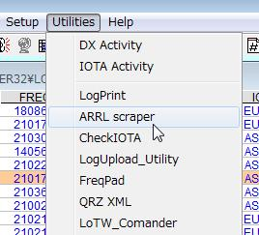

AS_1

Run ARRL Scraper and you will see:

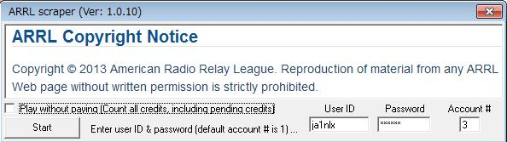

AS_2

### 2.1 User ID and Password

These are the User ID and Password you use to log on to the LoTW web site.

### 2.2 Account #

This is your account # which is provided by LoTW. If you have only one account then this is 1 (default). If you have multiple accounts then you have to know account # for each account.

To find your Account #, Log on to the LoTW web site with your browser.

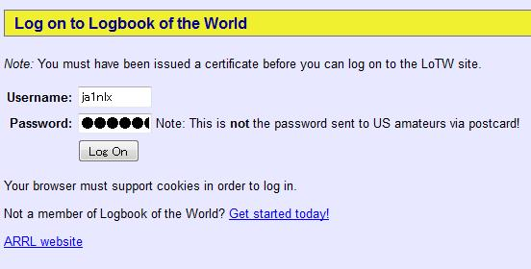

AS_3

Click the Awards tab



AS_4

~~Select "Your Account" and then Select the DXCC Award Account you wish to get the Account # for.~~ Under “Your LoTW ARRL DXCC (DX Century Club) Account(s)”, select account you wish to get the Account # for in the dropdown list. Click “Select DXCC Award Account”. In this sample Account 3D2YA is selected.

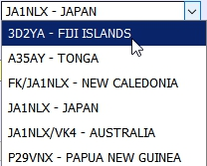

New AS_5

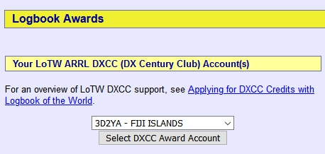

AS_5A

Look at the address line of your browser and you will find "_acct=n” This is the account # for this account. In this example, the Account # is "3". I have 5 accounts. JA1NLX account #=1, FK/JA1NLX account #=2, 3D2YA account #=3 etc.



AS_6

Make a note of all account #s and close browser.

### 2.3 Play without paying option

If this option is checked then it scrapes All credits QSO records (including pending credits). If this is unchecked then it scrapes Granted credits QSO records. (only awarded credits).

## 3.0 Operation

Click the <**Start**> button and as the processing progresses, the status of the processing will appear on the Status bar at the bottom of the window.

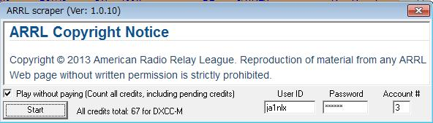

AS_7

If you check the Play without paying option you will get the following warning message:

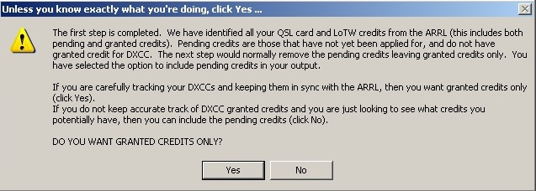

AS_14

If you want Granted credits only then select Yes

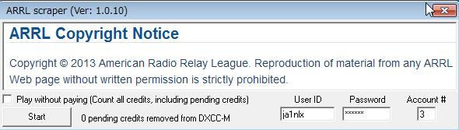

AS_13

**Note**: Play without paying option is unchecked even if it was checked. If you want all credits including pending credits then click No.

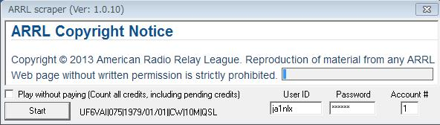

AS_8

The following status message indicates that you put the wrong User ID/Password/Account # or the internet connection is disconnected.

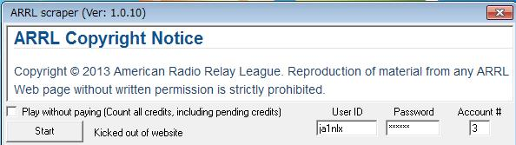

AS_9

It takes about 20 minutes or so for ARRL Scraper to scrape 1200 records. When it scrapes records successfully then these records are saved in a text file in the same folder as ARRL Scraper.exe and this window close automatically. The file name is dependent on the Play without paying option being checked or unchecked.

* + If this option is checked then the file name should be like JA1NLX_3_all_credits scraped data.txt, or,
  + if this option is unchecked then the file name should be like JA1NLX_3_granted_credits scraped data.txt.

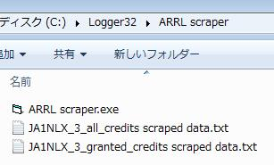

AS_10

The following example is part of the JA1NLX_3_granted_credits scraped data.txt.

.

4X4DK|336|2009/07/01|20:01:25|CW|30M|LoTW|https://lotw.arrl.org/lotwuser/qsodetail?qso=230235859

4X4JU|336|2012/03/20|04:39:44|CW|20M|LoTW|https://lotw.arrl.org/lotwuser/qsodetail?qso=415590602

4Z5LA|336|2009/07/02|04:06:36|CW|17M|LoTW|https://lotw.arrl.org/lotwuser/qsodetail?qso=230236001

5B4AHJ|215|2009/07/02|03:04:23|CW|17M|LoTW|https://lotw.arrl.org/lotwuser/qsodetail?qso=230235929

5B4AJC|215|2012/03/20|05:26:20|CW|20M|LoTW|https://lotw.arrl.org/lotwuser/qsodetail?qso=415590667

*Created with the Personal Edition of HelpNDoc:* [*Full-featured EBook editor*](http://www.helpndoc.com/create-epub-ebooks)